# The Design Tab

The design tab is sanctified to the document formats, layouts, themes, page backgrounds, and color schemes to make a document file look catchy, attractive and pleasing to eyes along with its information.

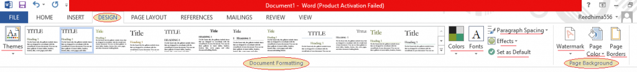

Under the Design tab, we only have two sections document formatting and page background to help the users to add the color theme and set a format to their document files and also to add creative background to the file.

## Document Formatting

The first section of Document Formatting helps the user to select the color theme for document format styles, a different color theme will give you different document format style, other than colors of a particular theme you can select your own colors for your document’s theme, select fonts, paragraph spacing, effects and if nothing works you can also set the settings as default to keep it simple in a single click.

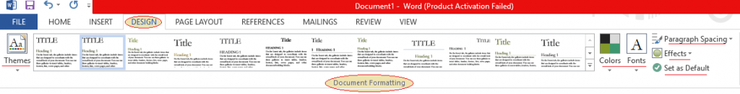

## Page Background

Next comes the Page Background section, where you can add watermark on your document such as Confidential, Sample, Do Not Copy, Urgent, ASAP, Draft, etc. you can also color your page background or add borders available in various designs to your document page.

